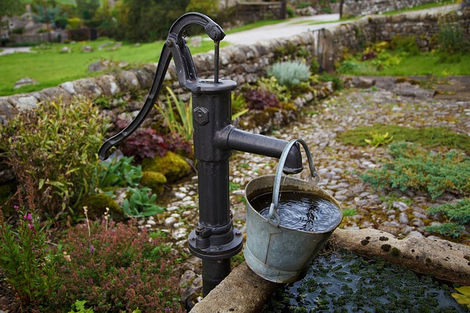  Protect Your Health by Testing Your Private Well Water  Wells can provide many years of clean water but will eventually deteriorate or become damaged. At this point, surface contaminants can enter the water. Some groundwater can contain one or more chemical substances in concentrations above state health limits.  There Are a Variety of Contaminants to Test For:  E. Coli  Coliform Bacteria  Nitrate  Lead  Arsenic  Secondary Contaminants (Iron, Hardness, Manganese, Sulfate)
  How to Get a Well Testing Kit
  - Pick up a water testing kit at the Pennington SWCD office.
  - Recommended to test for Nitrates, E. Coli and Coliform Bacteria.
    - Kit prices range from $35 to $50.
  - Additional analysis available for an added cost.
  - Collect your water sample and return with payment.
  - Courier service from your local SWCD office to a certified laboratory (RMB Lab).
  Local Certified Laboratories
  - RMB Environmental Laboratories, Inc.
  - AC: Analytical & Consulting
    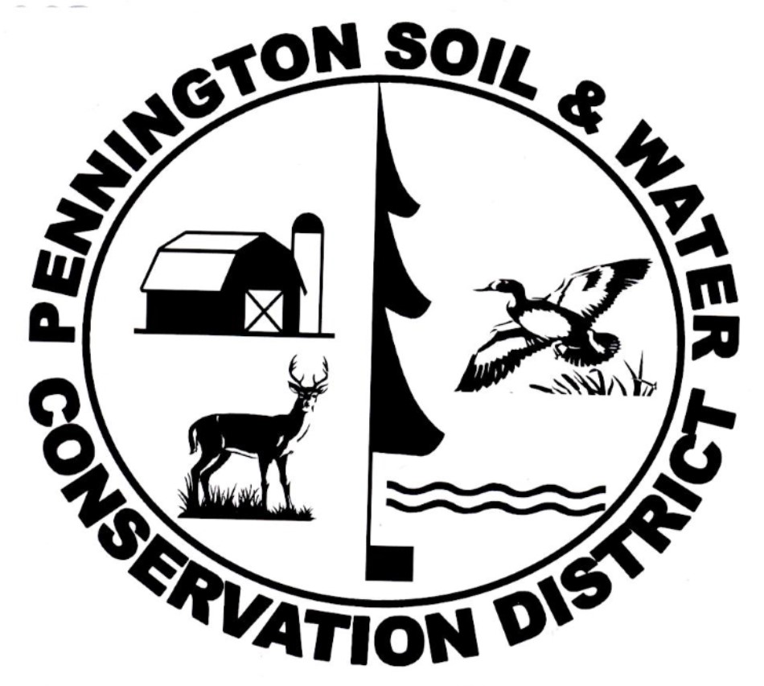 | Pennington SWCD  201 Sherwood Ave S  Thief River Falls, MN 56701  218-683-7075
  
  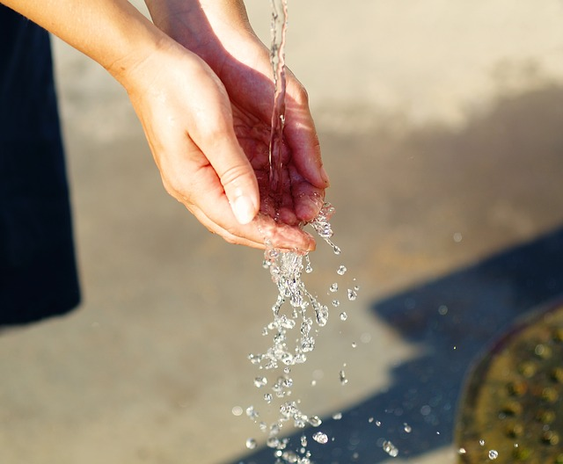
  Well Water Testing
    - PENNINGTON SOIL & WATER CONSERVATION DISTRICT
    - 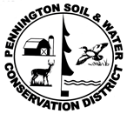
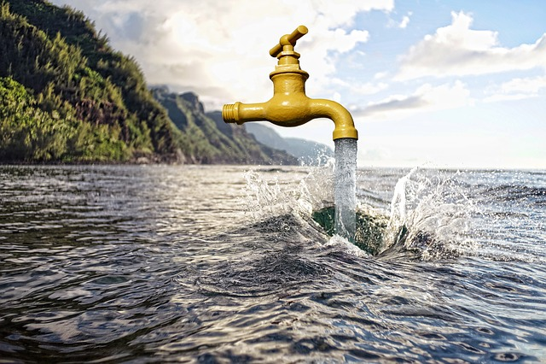  You Should Test Your Water When:  - Purchasing a home  - You are pregnant or nursing  - There are children or elderly in the home  - Living near livestock or heavily fertilized areas  - There is a change in odor, taste or appearance of your water  - Someone in the home has a digestive illness or vitamin deficiency  - A new well, pump, or treatment device has recently been installed  - You want to know the quality of the water you consume  E. Coli  If a sample is positive for E. coli, the water is contaminated with fecal matter. Most varieties of E. coli are harmless, but a few strains can cause severe health effects including abdominal cramps and vomiting. Test your well for E. coli every year. | Coliform Bacteria  These organisms indicate how sanitary your water system is. The presence of total coliform bacteria in drinking water indicates surface contamination. This test should be taken every year. If any coliform bacteria are detected, the well should be disinfected to ensure there are no infectious diseases.  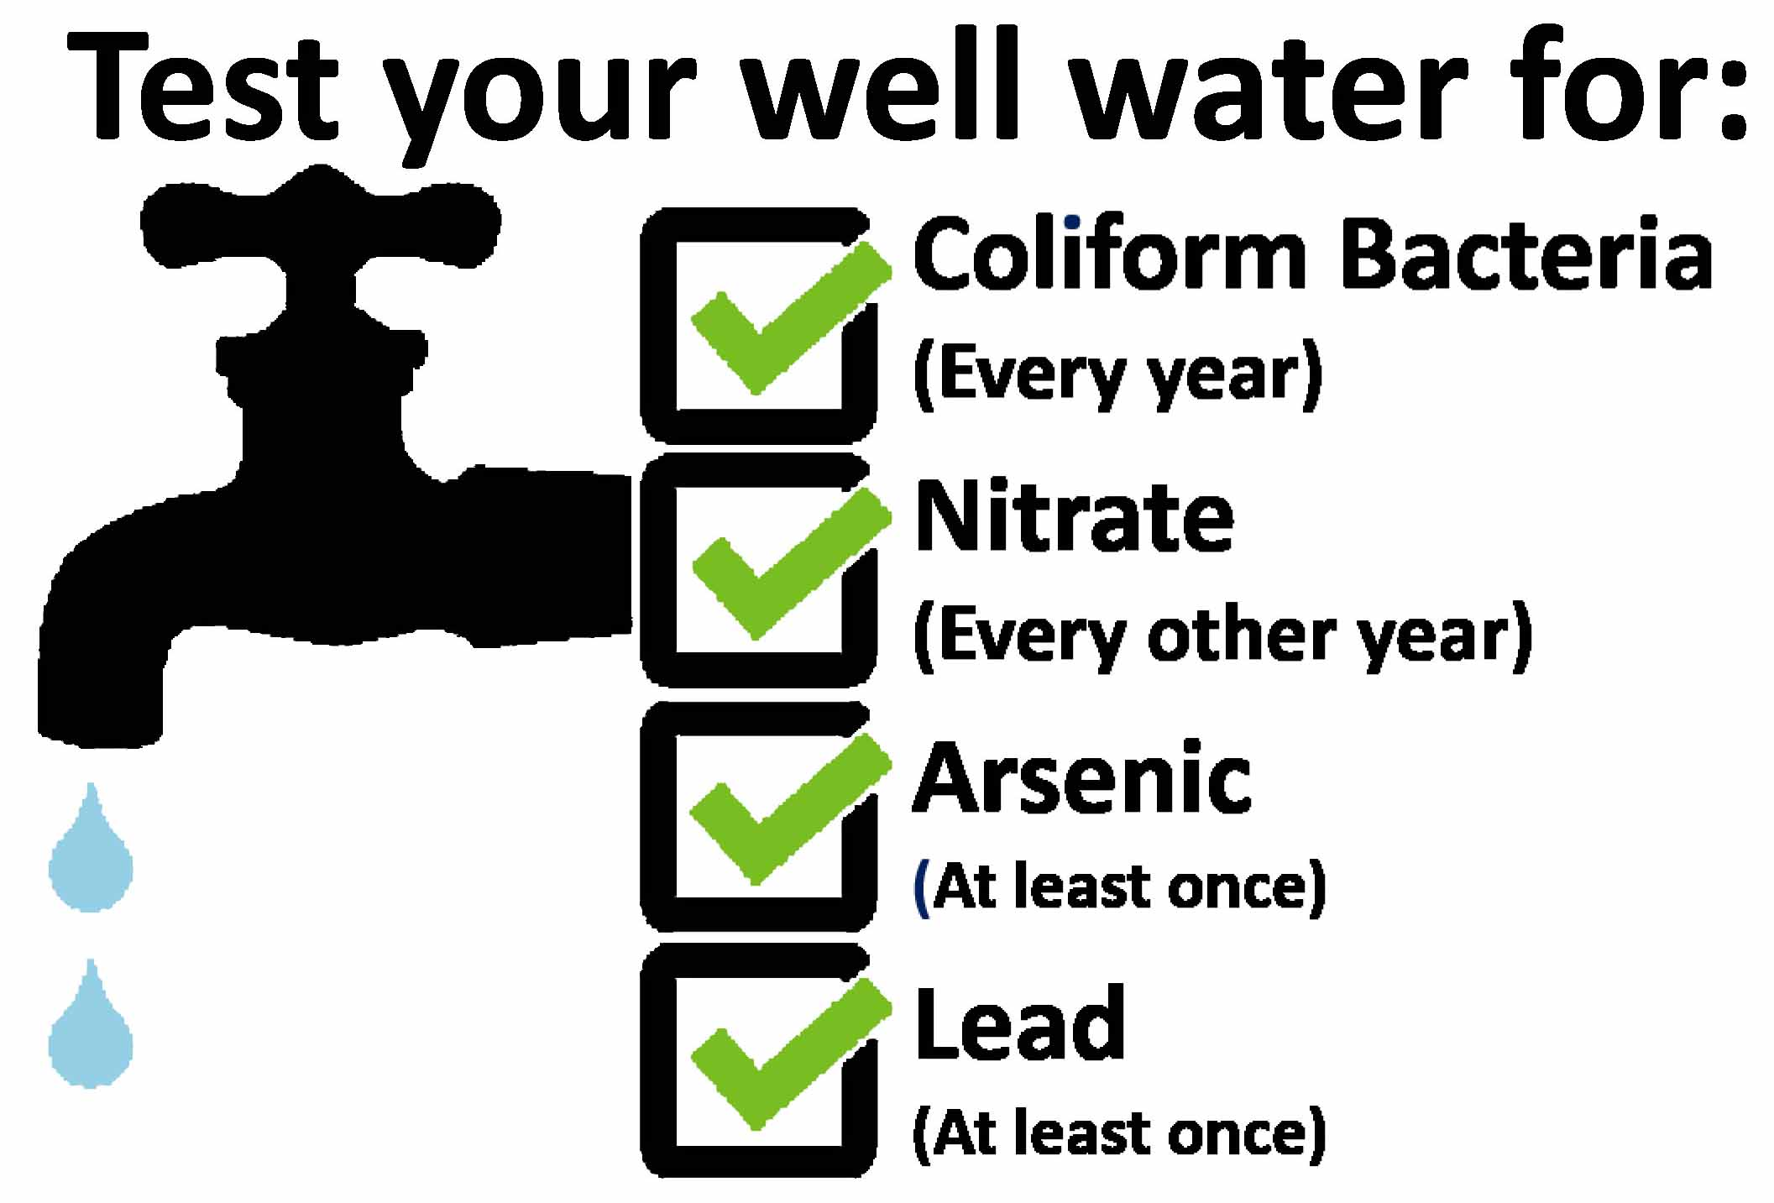  Nitrate  Nitrate is a compound that occurs naturally and has many human-made sources. You cannot taste, see or smell nitrate in your water. Increased nitrate levels in groundwater indicate contamination from fertilizers, animal wastes, or on-site sewage systems. This test should be taken every two or three years.  Lead  Pipes and other components of the household plumbing system may contain lead and may slowly dissolve into the water. Your well should be tested at least once for lead. | 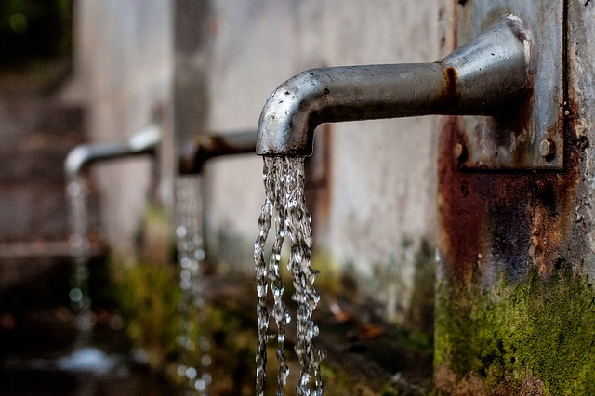  Arsenic  Arsenic occurs naturally in soil and rock and can dissolve into groundwater. Arsenic in water has no taste or odor. It is recommended that your well should be tested at least once for arsenic. Long-term consumption of well water with arsenic levels above federal drinking water standards should be avoided.  Secondary Contaminants  - Iron: Iron is not a health risk but leaves an unpleasing odor and taste in drinking water.  - Hardness: Hard water is high in minerals such as calcium and magnesium and does not cause negative health effects. Testing wells for hardness can help you develop an effective treatment program.  - Manganese: Manganese causes a metallic taste in water but is typically not a health concern.  - Sulfate: Sulfate reducing bacteria convert sulfate to hydrogen sulfide gas (rotten egg smell). Sulfate is a health risk particularly for infants.
Websites:
https://www.health.state.mn.us/communities/environment/water/wells/waterquality/tips.html
https://www.health.state.mn.us/communities/environment/water/docs/wells/waterquality/nitrate.pdf (brochure on nitrates)
https://www.ci.corcoran.mn.us/vertical/sites/%7BA13DB5FF-43A9-4A27-A5A0-44E78D9C28BC%7D/uploads/Test_your_Wells.pdf (MDH Well Testing brochure)
https://www.health.state.mn.us/communities/practice/conference/docs/2018sessions/station21handout.pdf

Pics:
https://pixabay.com/images/search/drinking%20water/?pagi=4
https://pixabay.com/images/search/clean%20water/?pagi=6

